

Insights from the Prescription Opioid Overdose Risk 2 study

**A community pharmacy intervention for patients   
prescribed high strength opioids for chronic non-cancer   
pain: Evaluating feasibility and acceptability**

Background

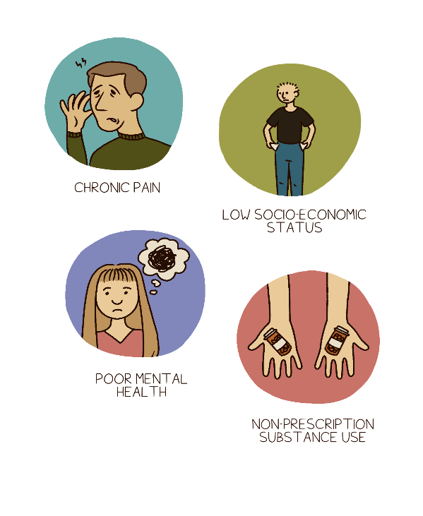Chronic pain is long term or persistent pain that lasts for more than three months. It affects 30% of people worldwide. Chronic pain

is linked to worse physical and mental health outcomes. It disrupts daily activities and affects sleep. Opioids may be effective for other types of pain, such as acute or cancer pain but are not as effective

for chronic non-cancer pain (CNCP).

High strength opioids are not the first recommended treatment

for CNCP but increasing numbers of patients in Scotland are   
prescribed them. Some patients prescribed high strength opioids for pain can be at risk of overdose and reducing these risks is important. Harm reduction interventions are usually reserved for those using   
illicit opioids or in treatment such as Opioid Agonist Treatment.

CNCP patients, family members, and community pharmacists worked with researchers to design an intervention to reduce the risk of opioid overdose for CNCP patients in the ‘Prescription Opioid Overdose Risk 1’ study. The intervention is designed for delivery in community pharmacy settings and includes overdose awareness education, naloxone training and supply (naloxone is a drug that can reverse opioid overdoses).

Our study aim

In the following study - Prescription Opioid Overdose Risk 2 - we evaluated the feasibility and acceptability   
of the new intervention from the perspective of patients and the community pharmacists delivering it.

Key findings

* Patients and pharmacists agreed that the provision of prescription opioid overdose information to

a group who are often overlooked in harm reduction interventions was acceptable and understandable.

* Patients prescribed opioids for CNCP have no, or very low, overdose awareness or knowledge.   
  They considered themselves to be at very low risk of opioid overdose.
* Patients were uncertain about taking part in the intervention because they did not see themselves

as being at risk of overdose. However, those who took part in the intervention were satisfied with  
it being delivered by community pharmacies.

* Pharmacists identified gaps in their own knowledge through participation in the intervention.
* Pharmacists thought the intervention was good value for the time and resources involved.   
  They also thought that the compensation provided for participating in this study was fair.

Who could take part and how?

Pharmacists working in community settings could deliver the intervention in person in community pharmacies or remotely

via video conferencing software​.

CNCP patients could take part if they were:

* taking 50mg or more of morphine equivalent daily
* not receiving Opioid Agonist Treatment
* over 18 years old
* living with others or had regular visitors.

Study design

We used a mixed methods design which involved collecting and analysing quantitative data (numbers)

and qualitative data (what people said about the intervention). Patients were approached by community pharmacists. If they agreed to take part, the research team contacted them to make sure they had all

the information to make an informed choice. Before the intervention, patients completed a questionnaire about their details, health, prescribed medication, alcohol use, and non-prescription drug use. Then the pharmacists delivered the intervention.

After the intervention, we invited patients to a telephone interview to talk about the intervention

with researchers. Pharmacists were also invited to a telephone interview to talk about their views

of the delivery and the content of the intervention. People with experience of CNCP helped to choose

the topics and questions covered in the interviews. Six months later, patients filled in another questionnaire which included questions about their view of the intervention.

The questionnaire results were analysed using descriptive statistics. This allowed us to see any changes at group level and describe who took part in the intervention. Interviews were analysed using the Framework Method approach. This allowed us to identify themes that were expressed frequently by the participants

as a group of patients, and group of pharmacists.

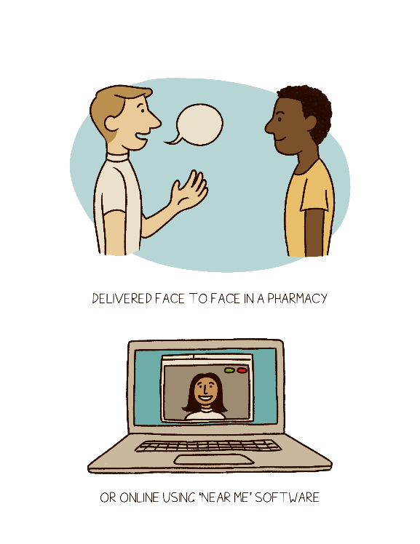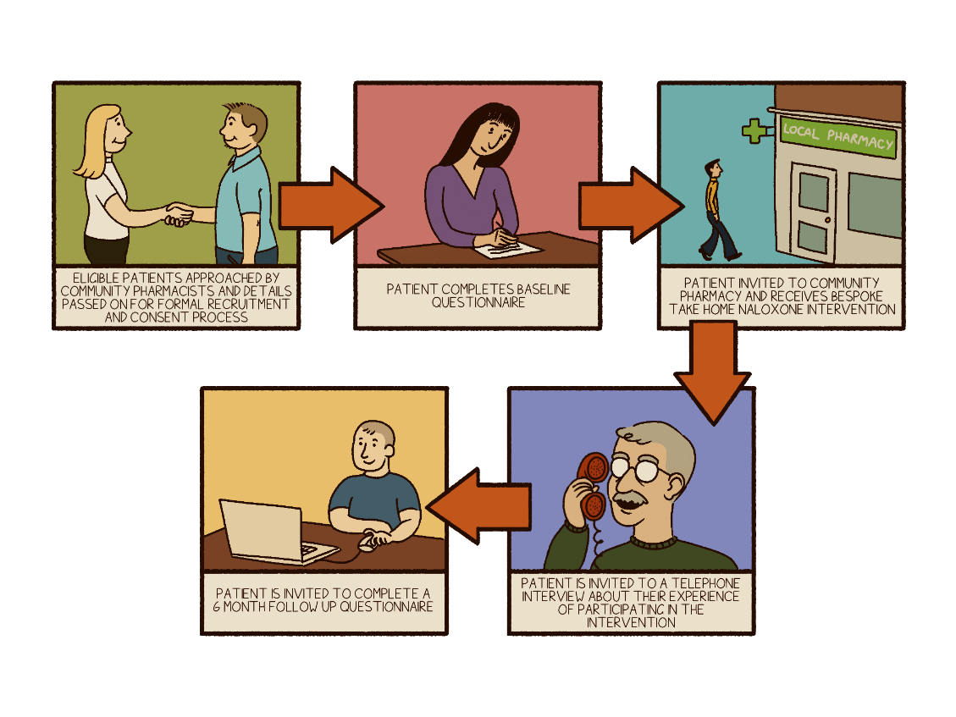

Who took part?

* 12 patients completed the intervention at   
  three community pharmacies in NHS Grampian
* 12 patients completed the baseline questionnaire and 3 completed the 6 month follow up
* 7 patients completed a telephone interview
* 4 community pharmacists completed

a telephone interview

Questionnaire results

Patients were aged 33 to 74 years old.

All were white and ¾ were men.

Two patients were taking one pain medication only.

Four patients were taking four pain medications together. One patient

was taking eight pain medications.

All patients were taking opioid   
painkillers (this was one of the   
criteria for joining the study).   
Patients were taking a range of other medications, shown in the graph to the right.

**Table 1. Prescription Opioid Misuse Index**

|  |  |
| --- | --- |
| **POMI risk factors** | **Number of patients** |
| Use pain medication more often than  is prescribed | 3 |
| Need early refills for pain medication | 3 |
| Gone to a different doctor or an A&E unit to try and get more pain medication | 1 |
| Take a higher dose than prescribed | 0 |
| Feel high or get a buzz after using pain medication | 0 |
| Take pain medication because upset, or to relieve or cope with problems other than pain | 0 |

Patients completed the Prescription Opioid Misuse Index (POMI) (*see Table  
1 on left*) before the intervention.

Identifying two or more risk factors

on the POMI is thought to indicate ‘opioid use disorder’.

Four patients had medication-related risk factors and one person met the criteria for opioid use disorder.

We didn’t have enough patient participants to analyse the follow up questionnaire.

Patient views about the intervention

In qualitative analysis of the seven patient interviews, we found three main themes, with subthemes  
within each (*see Table 2 below*).

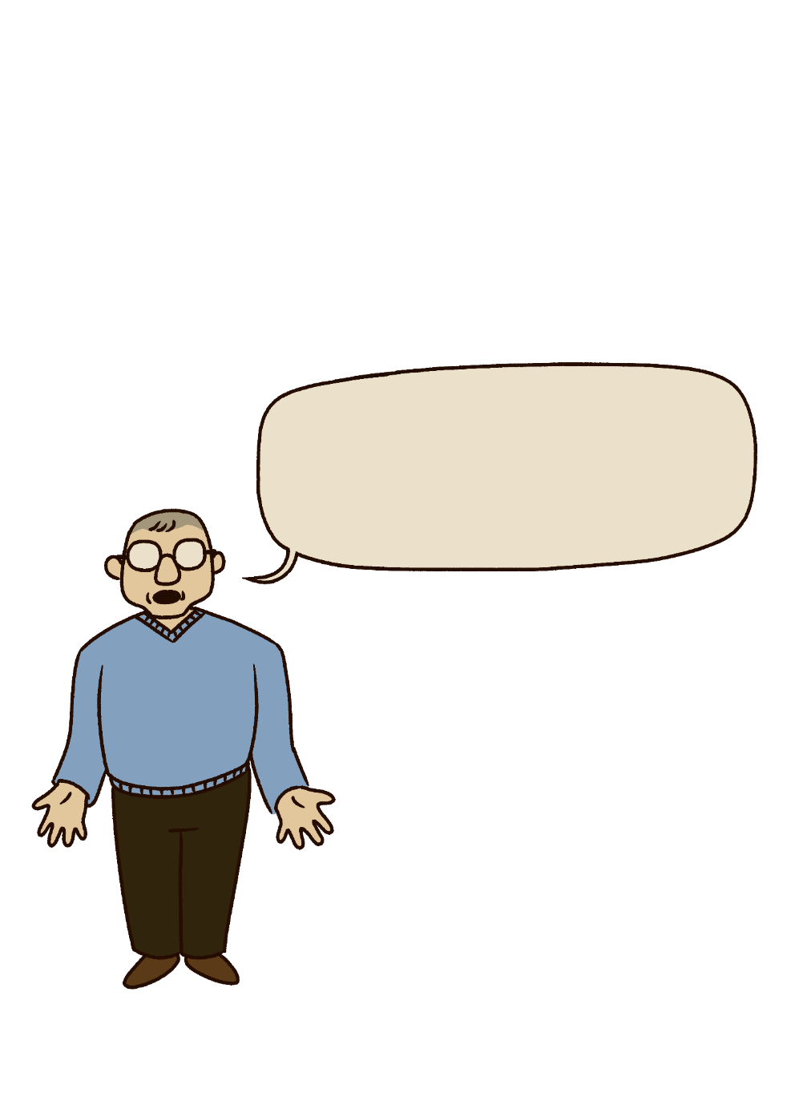

Patients tended to have low overdose awareness and knowledge before the intervention. Most did not know the signs

*I thought, it would be alright if I was missing tablets if I forget. And take extra and that. I thought everything would be okay (Man, 65)*

of an opioid overdose, or how to help during

an opioid overdose. Some patients did not know how to reduce the risk of overdose,

and some did not have basic information

such as how important it is to take their prescription the way it is prescribed.

Patients thought they were at low risk of opioid overdose as they saw this as a very unlikely event. This led to some patients being initially uncertain about their need for an overdose prevention intervention. They thought that

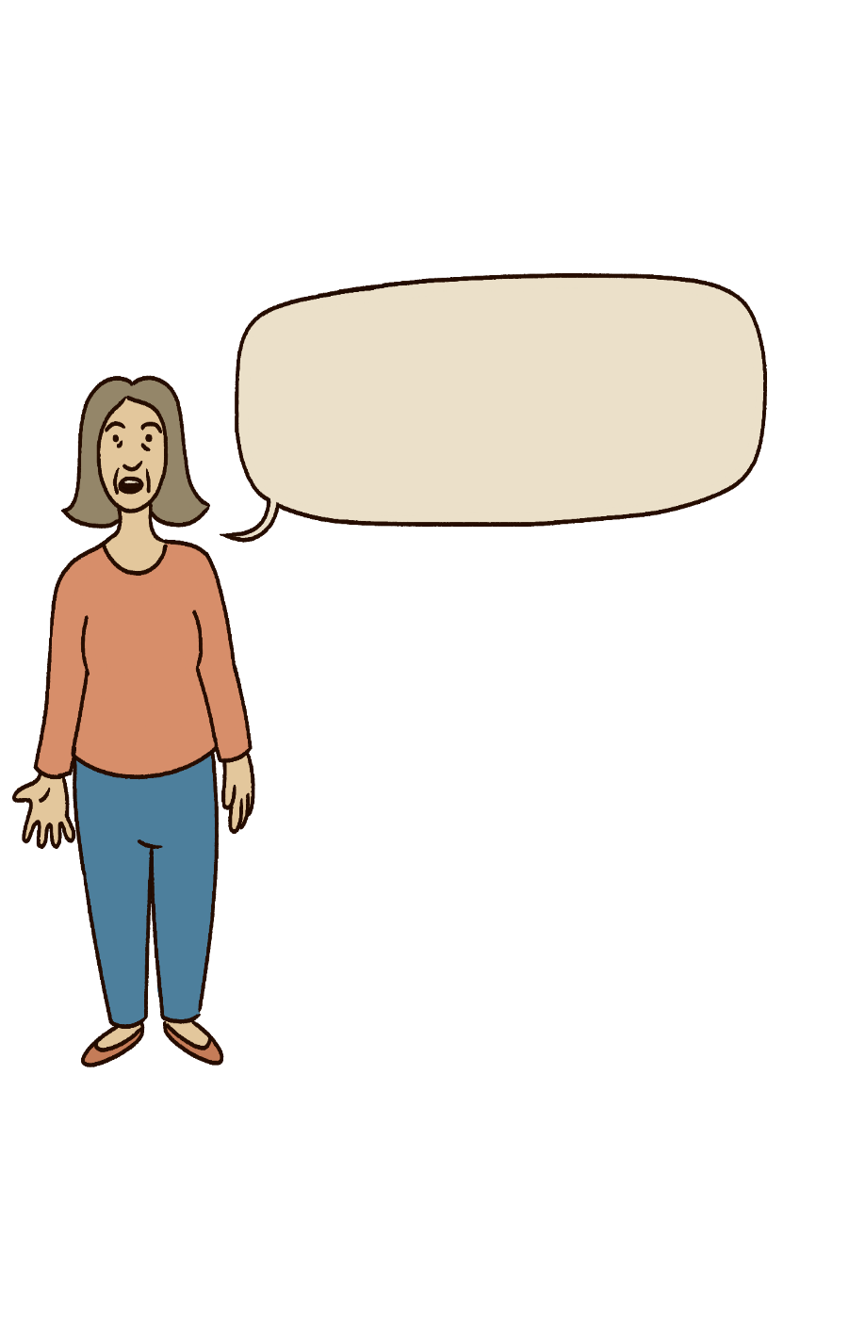it was very unlikely they would need naloxone.

*It kind of took me aback, if you know what I mean. It made me feel like somebody was finally looking after me if I am on a medication like this (Woman, 57)*

At the start, patients thought opioid overdose interventions were more suited to people who   
used non-prescription/illegal drugs. But, after the intervention, all patients could see that they were also at risk of overdose because of their prescription opioids. All the patients saw the value in a naloxone intervention for CNCP patients by the end of   
the study. Patients learned about the risks of prescription opioids, sometimes for the first time.

Following the intervention, patients were more

aware of the risks associated with prescription opioids, understood how to reduce the risk of  
opioid overdose, and knew what to do if they suspected an overdose.

**Table 2. Themes and subthemes in the analysis of patients’ views**

|  |  |
| --- | --- |
| Theme | Subthemes |
| Relationship with health, medication, and overdose | Participant health  Wider health context and experiences  Relationship with, and conceptualisations of, medication  Overdose risk |
| Experiences and perceptions of support | Relationship with community pharmacist  Support during intervention |
| Perceptions of intervention and participation | Intervention content  Relationship with naloxone  Intervention delivery  Improving the intervention  Participation in research |

Community pharmacist views about the intervention

In our analysis of interviews with pharmacists we identified themes with further subthemes (*Table 3*).

Pharmacists thought that patients had low overdose awareness and knowledge, and that patients didn’t think they were at risk because of prescription opioids. They found some patients didn’t know basic information that would help them fully understand the risks. Some patients didn’t know that their medication was an opioid.

*Recruits were very surprised to learn that tramadol was morphine based (Pharmacist 3)*​

Like patients, pharmacists thought the intervention addressed a gap in knowledge and awareness about the risk of prescription opioids. As well as providing patients with essential awareness and knowledge, pharmacists found that participating improved their own knowledge about overdose risk and harm reduction for CNCP patients.

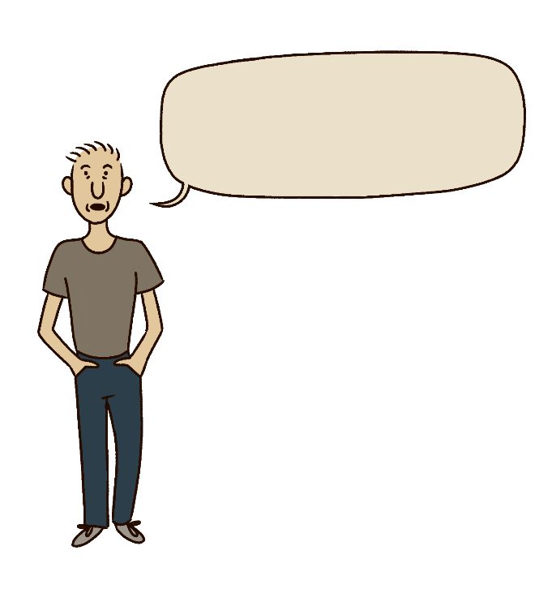

The intervention was delivered during COVID-19 restrictions which put pressure on community pharmacies. They wanted to spend more time

*So, like we do that for substance misuse, but not for people who take prescribed opioid drugs (Pharmacist 2)*

on the intervention but experienced barriers like staff being off work. Pharmacists thought that patients accepted the intervention and that it was a positive experience for patients and themselves. Pharmacists thought the intervention was good value for the time and resources involved, and the compensation

provided for taking part was fair.

​Pharmacists talked about communication breakdowns between the person who prescribed the opioids

and the patient. This led to information on risks

not being given to the patient. Pharmacists felt

it was left to them to talk about the risks. Some pharmacists noted that, before the study, they

did not talk about overdose risk with patients prescribed opioids for CNCP. They usually only did   
this with patients who had substance use difficulties.

**Table 3. Themes and subthemes in the analysis of pharmacist views**

|  |  |
| --- | --- |
| Theme | Subthemes |
| Pharmacy context and naloxone perspectives | Wider health and pharmacy context  Previous experience with opioids  Perspectives of naloxone |
| Patient risk awareness and suitability for the intervention | Patient medication and risk knowledge  Patient suitability and recruitment |
| Perceptions of the intervention and delivery | Participation in research  Participation for intervention delivery  Intervention delivery  Intervention content  Barriers to intervention participation and delivery  Improving the intervention |

Strengths and limitations

We didn’t have as many participants as originally planned. COVID-19 put pressure on community pharmacies, making it difficult for them to participate. Many patients didn’t think they were at risk of opioid overdose   
so the intervention didn’t seem like it was for them, and so they were uncertain about participating.   
Finally, the way we recruited people wasn’t as streamlined as it could have been. Before pharmacists   
could start the intervention, they had to pass patient information to the research team for formal recruitment. This meant that opportunities to recruit and intervene could have been missed.

Only patients who came into the pharmacy were recruited. The intervention could be delivered using   
video conferencing, but community pharmacists did not always have the capacity, knowledge, and/or software to use it. Patients would have also needed to have the digital devices to accept these appointments. Developing remote delivery processes with support for pharmacies could make the intervention accessible

to more patients in the community, such as those who have their prescription opioids delivered to them

at home.

A cartoon drawing showing a green cross (symbolising the pharmacy) with outstretched arms holding a syringe in one hand and a dropped in the other.

Patients with CNCP felt positively towards the intervention.

Patients and pharmacists agreed that it delivered prescription opioid overdose information to people who are often overlooked

in harm reduction interventions. They agreed it was acceptable

and understandable.

Implications for practice and research

* It is important to consider the way that overdose risk and related interventions (like take-home naloxone)

are communicated with patients with CNCP. This should be done in a non-judgemental way that helps patients understand that they have a risk of overdose, and that describes naloxone as a safety measure.

* Increasing remote delivery of the intervention could make the intervention accessible to more patients in the community. This requires support for community pharmacists to develop the remote delivery skills.

About this research

This study was funded by the Scottish Government Drug Deaths Taskforce and led by Dr Fiona Mercer,

Dr Rebecca Foster, and Prof Tessa Parkes, with Joe Schofield, Kristina Hnízdilová, Prof Catriona Matheson, Wez Steele, Dr Andrew McAuley, and Prof Alexander Baldacchino. We want to say a big thank you

to our practice advisers in NHS Grampian, Fiona Raeburn and Lucy Skea, Specialist Pharmacists in Substance and Medicines Use, our participants, Expert by Experience group, and Research Advisory Group members.

For wider reading please see the Medicines and Healthcare products Regulatory Agency guidance [Opioids:  
risk of dependence and addiction - GOV.UK (www.gov.uk)](http://Opioids:risk%20of%20dependence%20and%20addiction%20-%20GOV.UK%20(www.gov.uk)) with a recommendation that all prescribers and health care professionals should discuss risks associated with opioids, including risk of unintentional overdose.

Related publications

* Schofield J, Steven D, Foster R, Matheson C, Baldacchino A, McAuley A, et al. Quantifying prescribed high   
  dose opioids in the community and risk of overdose. *BMC Public Health 2021;* 21:1174
* Parkes T, Foster R, McAuley A, Steven D, Matheson C, Baldacchino A. Chronic pain, prescribed opioids,

and overdose risk: A qualitative exploration of the views of affected individuals and family members.   
*Drugs: Education, Prevention and Policy* 2022:1-12

* Mercer F, Parkes T, Foster R, Steven D, McAuley A, Baldacchino A, Steele W, Schofield J, Matheson C. Patient, family members and community pharmacists’ views of a proposed overdose prevention intervention delivered in community pharmacies for patients prescribed high strength opioids for chronic non-cancer pain: an explorative intervention development study. *Drug and Alcohol Review* 2022; 1-10

**Contact:** Salvation Army Centre for Addiction Services and Research, University of Stirling 🖂 [SACASR@stir.ac.uk](mailto:SACASR@stir.ac.uk)